ESP32-S3 + ICS43434 Mic Array

- ESP-IDF - install
  - Download and install (install in C drive, no need to install in the dev Derive) from here: https://dl.espressif.com/dl/esp-idf/
  - Double-click desktop "ESP-IDF 5.5 CMD" – verify installation
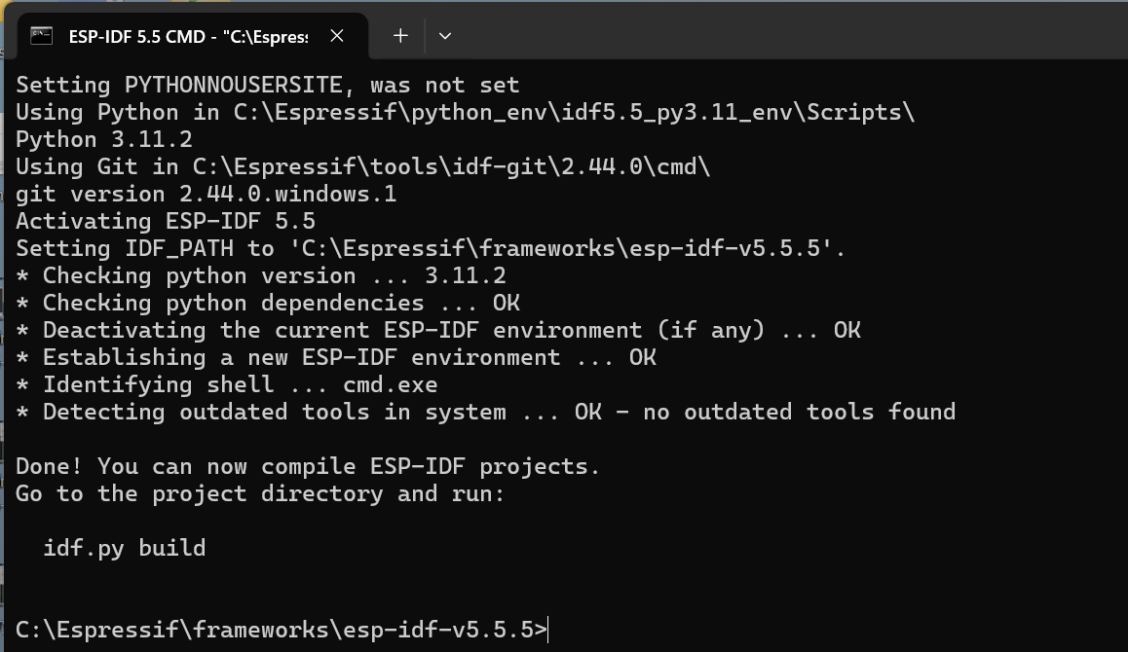
- ESP-IDF – sanity check
  - Go to the hello world building example:
cd C:\Espressif\frameworks\esp-idf-v5.5.5\examples\get-started\hello_world
dir
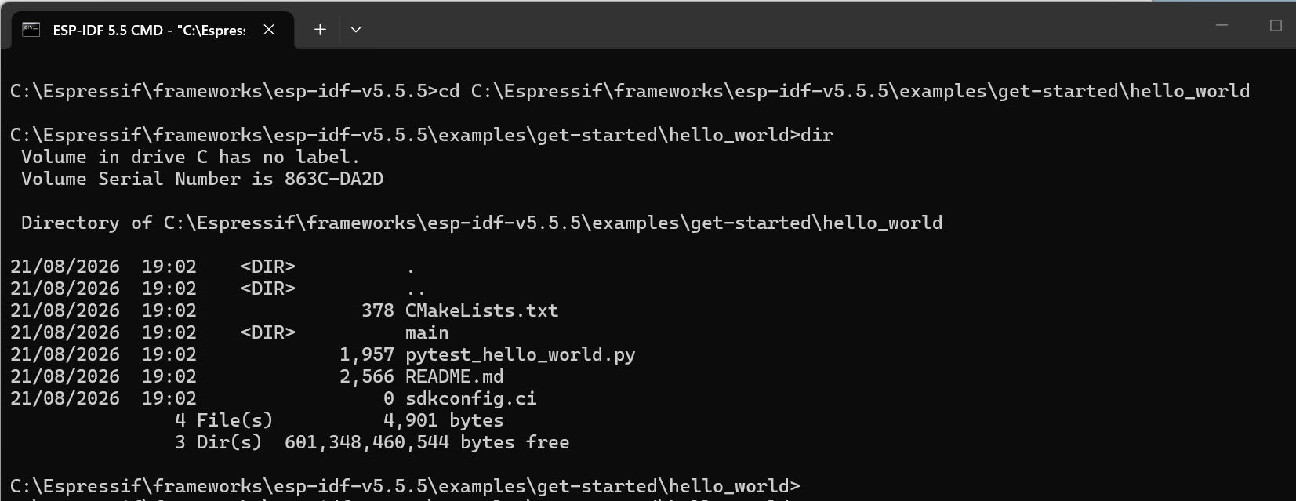

  - Set the target chip to ESP32-S3:
idf.py set-target esp32s3
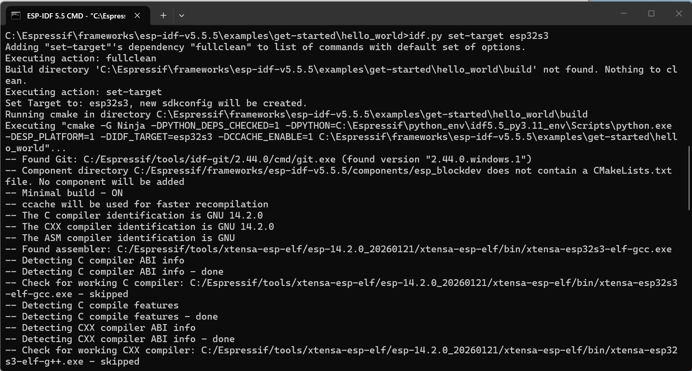
  - Build et sanity test:
idf.py build
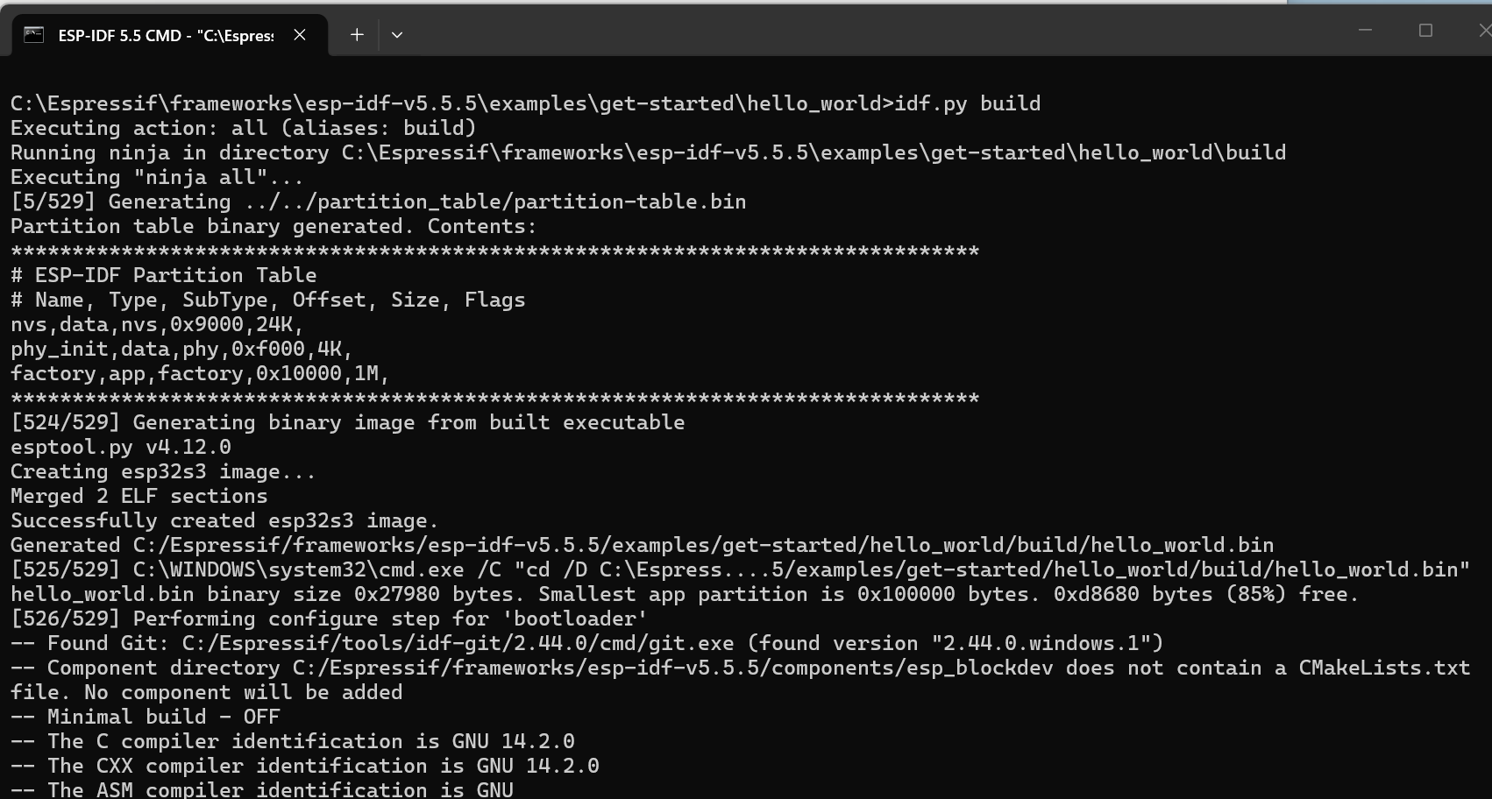
  - Plug in the USB in this one:
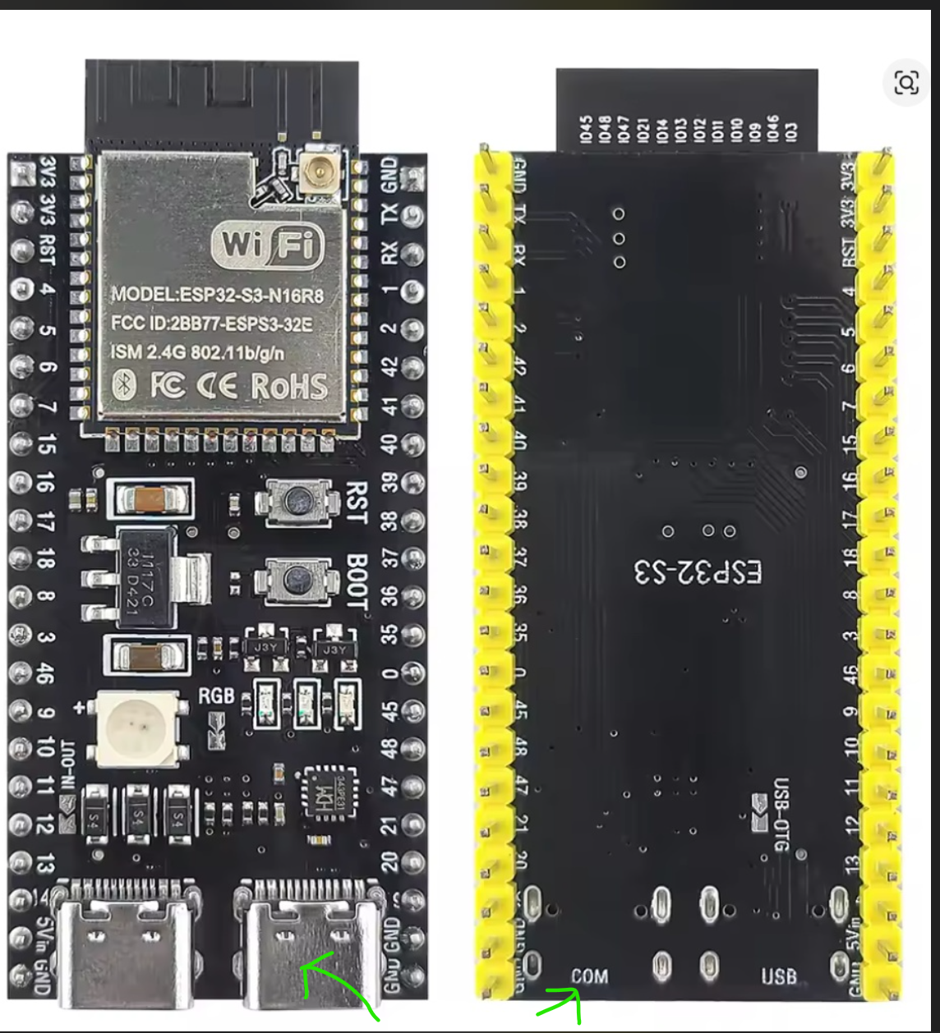
  - Get the COM number from the Device manger
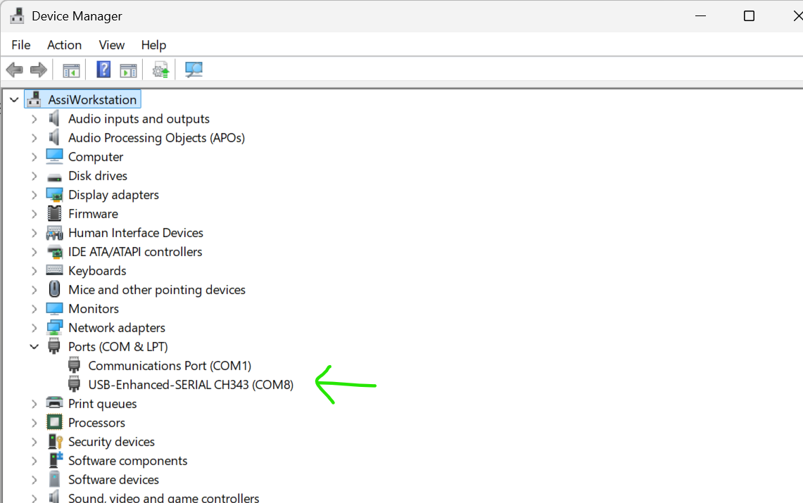
  - Run, in this example it is for COM8 (and get red led on, green led flashing):
idf.py -p COM8 flash
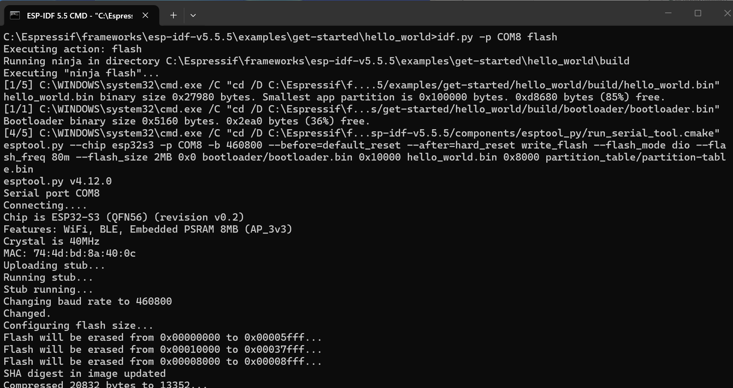
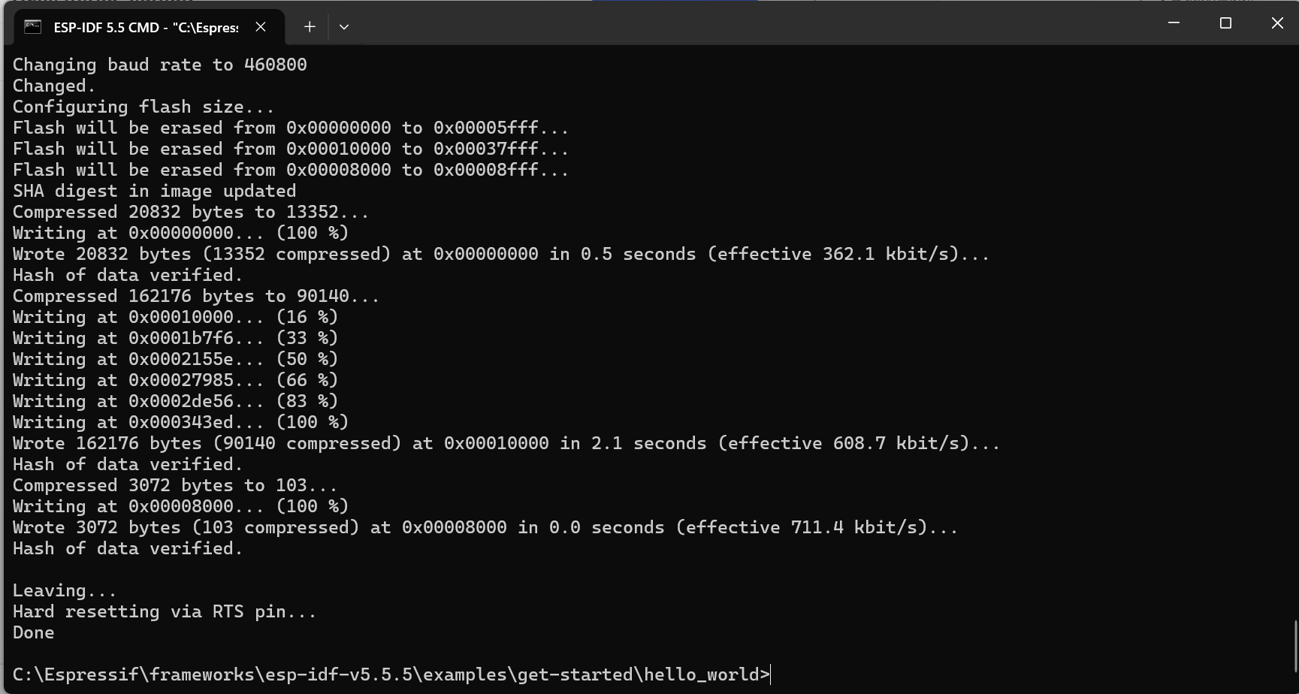
  - Open the serial monitor to see the actual "Hello world!" output:
idf.py -p COM8 monitor
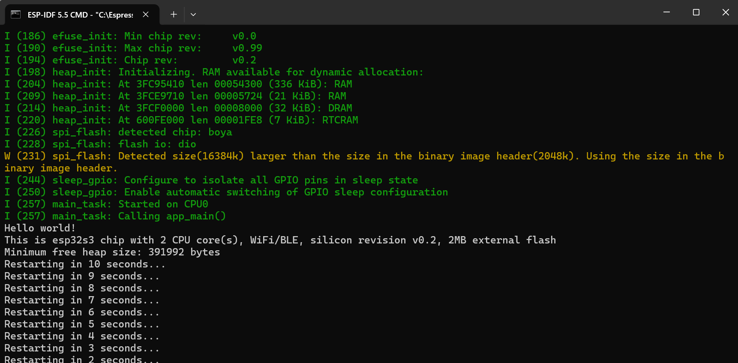
  - Toolchain confirmed, board confirmed alive and flashed via ESP-IDF.
To stop it: CTRL + ]
- Board Running
  - With code changes
  - From D:\Dev\AccPhy_Project\Esp32s3_ics43434_mic_array
  - Build:
idf.py build
  - Flash and run:
idf.py -p COM8 flash monitor

